CYCLES IN NATURE

Elements such as carbon, oxygen, hydrogen, nitrogen and sulphur are recycled in nature - this is the role of the decomposers.

Carbon Cycle

The element carbon is one of the main materials in sugars, proteins and fats - these are found in the tissues of all living things. Carbon is also found in vitamins, as well as in waste products such as CO₂ and urea.

In the carbon cycle, plants convert CO₂ to food and O₂ during photosynthesis.

Animals (and plants at night) produce CO₂ during respiration.

On decomposition, all plant and animal material is reduced to CO₂ by the decomposers, and the residual nutrients are returned to the soil.

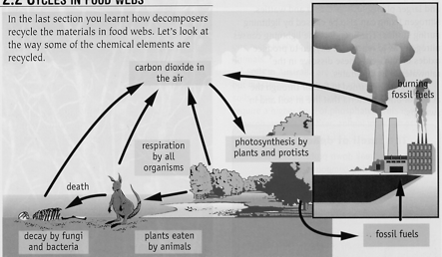

Nitrogen Cycle

Nitrogen makes up 78% of the atmosphere, is found combined with oxygen as nitrates in the soil, and is one of the elements found in proteins (these are the building blocks of cells and tissues).

Animals obtain their nitrogen either from plants or other animals.

Plants get their nitrogen from the nitrates in the soil. They are soluble in water and are easily absorbed by plant roots.

Nitrates can be formed in the following ways.

• The decay of dead organisms by decomposers.

• Atmospheric nitrogen changed by nitrogen-fixing bacteria in the soil and
in nodules on the roots of legumes such as clover, peas and beans.

• Lightning causes atmospheric nitrogen N₂ to react with O₂ to form oxides
of nitrogen. These form nitrates when they dissolve into water.

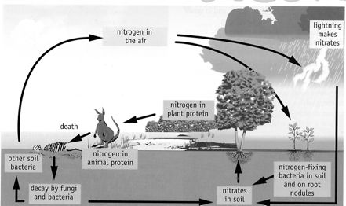

THE WATER CYCLE

97% of the world’s water is in the oceans, 2% in glaciers and 1% is in surface streams / rivers and underground.

The Sun continuously evaporates water from the soil, streams, lakes, etc. Plants and animals transpire and respire. The vapour rises to higher parts in the atmosphere where it cools and forms clouds. As the droplets grow in size, they fall as rain. The water eventually finds its way back to the ocean via underground, streams and rivers. The cycle then continues.

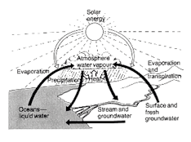

Time scale for the cycle

• Water in the atmosphere is replenished every 10 days.
• Streams / rivers is weeks.
• Soil is months.
• Ground water is hundreds of years.
• Ice caps is thousands of years.

The diagram below shows the water flow from the Gnangara Mound in the northern suburbs of Perth.

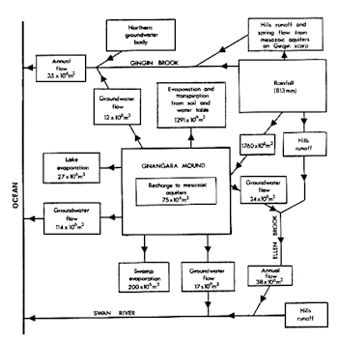

Most, if not all, of the water used in the northern suburbs comes from below the ground.

